**Model Testing**

Using the seven models provided from the workshop, I tried every one of them to get a general feel of which model performs better. I also did some very light edits to some of the models to help them perform better without using up too much of my time.

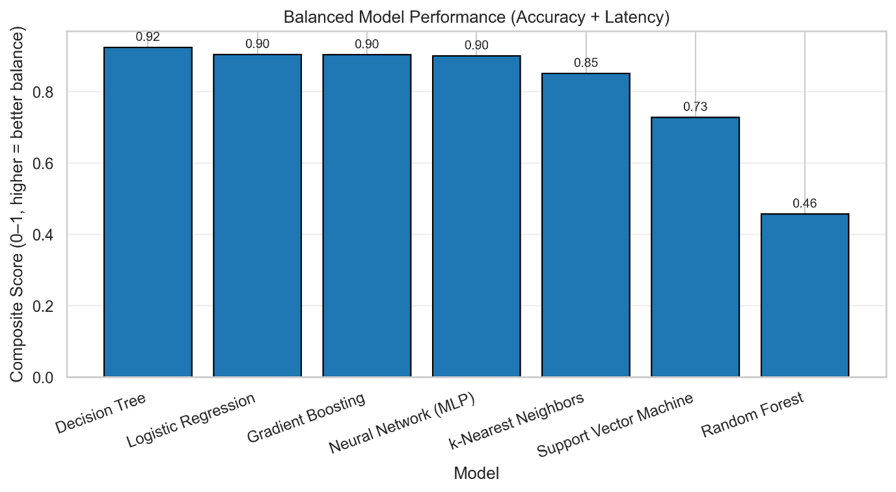Using a balanced model performance graph using Balanced Accuracy, F1 Macro and Prediction Time, as well as comparing the False Positives, False Alarms, and Gray Area values from each model, Neural Network (MLP) and k-Nearest Neighbours were the first 2 models I excluded. Their False Positive rates were too high to be considered. SVM still had comparatively high False Positive rates while Random Forest models were much slower (0.06s) compared to the other models (<0.01s). I decided to keep Decision Tree (for having the lowest False Positive rate) and Gradient Boosting (for its extremely low False Alarm rates) to do more detailed testing.